Smart Bus Cashless Payment System: NFC Scanning With Mobile And Web Application

Senior Project
by
Hussein Azzam,
Mahmoud Abo Khalil

Submitted to the School of Engineering of the
Lebanese International University
Tyre, Lebanon
in partial fulfillment of the requirements for the degree of

BACHELOR OF SCIENCE IN COMMUNICATION ENGINEERING
Spring 2024-2025

Approved by:
Supervisor

Dr. Hadi Noureddine

Committee Member

Dr. TBA

DEDICATION

To someone I know and I care for
Hussein Azzam

To someone I know and I care for
Mahmoud Abo Khalil

ACKNOWLEDGMENT

We would like to thank our supervisor and the dean and the rest of the people who spared no effort in
ABSTRACT

The abstract goes here with double space 12pt font. The abstract consists of one paragraph with first line indentation. The page should be numbered. The abstract goes here with double space 12pt font. The abstract consists of one paragraph with first line indentation. The page should be numbered. The abstract goes here with double space 12pt font. The abstract consists of one paragraph with first line indentation. The page should be numbered. The abstract goes here with double space 12pt font. The abstract consists of one paragraph with first line indentation. The page should be numbered. The abstract goes here with double space 12pt font. The abstract consists of one paragraph with first line indentation. The page should be numbered.

TABLE OF CONTENTS

ACKNOWLEDGMENT iii
ABSTRACT iv
TABLE OF CONTENTS v
LIST OF FIGURES viii
LIST OF TABLES ix
LIST OF SYMBOLS x
CHAPTER 1 INTRODUCTION 1
1.1 Background 1
1.2 Problem Statement 1
1.3 General overview of the project 1
1.4 Thesis Outline 1
CHAPTER 2 Survey of Existing Methods and Similar Systems 2
2.1 Introduction 2
2.2 Method 1 / System 1 2
2.3 Method 2 / System 2 2
2.4 Method 3 / System 3 2
2.5 Methods/Systems Comparison 2
2.6 Conclusion and Motivation 3
CHAPTER 3 System Design 5
3.1 Introduction 5
3.2 Requirements and Specification Analysis 5
3.2.1 Functional Requirements 5
3.2.2 Use Case Diagrams 5
3.3 System Architecture 6
3.4 Class Diagrams 6
3.5 Sequence Diagrams 6
3.6 Activity Diagrams 7
3.7 Entity-Relationship (ER) Diagrams 7
3.8 Non-Technical Aspects 7
3.8.1 Financial Viability 7
3.8.2 Stakeholders 8
3.8.3 Scope 8
3.8.4 Risks 8
3.8.5 Schedule and Milestones 9
3.8.6 Ethical and Social Considerations 9
3.8.7 Environmental and Sustainability Considerations 9
3.8.8 Relevant Standards 10
3.9 Conclusion 10
CHAPTER 4 Implementation/Simulation and Testing 11
4.1 Introduction 11
4.2 Implementation Tools 11
4.3 Implementation Summary 11
4.4 Test Cases and Acceptance Criteria 11
4.5 Conclusion 11
CHAPTER 5 Conclusion and Future Work 12
5.1 Conclusion 12
5.2 Future Work 12
APPENDIX A: Implementation Details 13
APPENDIX B: USER Manual 14
APPENDIX C: deployment and configuration Manual 15
REFERENCES 16

LIST OF FIGURES
Figure ‎2.1. Menu bar of MS Word [1] 2

LIST OF TABLES

No table of figures entries found.

LIST OF SYMBOLS

MUST LISTED IN ASCENDING ALPHABETICAL ORDER. Examples:
Ω: Resistance
μ: Viscosity
A: Ampere
BW: Bandwidth
CD: Compact Disk
COVID: Corona Virus Disease
ISO: International Standardization Organization
LCD: Liquid Crystal Display
LIU: Lebanese International University
WiFi: Wireless Fidelity

INTRODUCTION

Background
In the world of technology, it has evolved to become not just a part of the human life, but rather an integral essence of life it-self. From the moment we wake up to the time we rest, we interact with technology in ways that enhance our daily experiences, connect us to others, and streamline our tasks. It has become a catalyst for innovation, empowering individuals and businesses to achieve new heights and transform industries. Technology not only complements human life, but it drives progress, amplifying our capabilities and opening up boundless opportunities for growth and development. The creation of this new technology project is a testament to the immense potential that lies within the intersection of creativity, innovation, and technology. As we harness the power of technology, we have the ability to shape a future that is more efficient, more connected, and filled with endless possibilities. This project will contribute to a vision where technology continuously elevates human experiences, creating a brighter and more dynamic world for all.

Problem Statement
The traditional bus fare payment system, which typically relies on cash or paper tickets, often leads to several issues, such as delays in boarding, long queues, and inconvenience for passengers who may not carry the exact change. Moreover, these systems are prone to errors and fraud, creating inefficiencies and dissatisfaction among passengers and operators. The absence of a seamless and automated payment mechanism also limits the scalability and modernization of urban transportation systems.

General overview of the project
The SmartBus Cashless Payment System is a modern solution designed to streamline bus fare collection using NFC (Near Field Communication) technology and QR code scanning. This system eliminates the need for cash payments, offering passengers a secure, contactless, and efficient way to pay their fare while providing real-time information on bus locations and estimated arrival times.
The system consists of two mobile apps and a web app. The bus-side mobile app, installed on each bus, uses an NFC reader to collect payments and a GPS tracker to send transaction and bus location data to Firebase and Firestore. Additionally, passengers can scan a QR code displayed on the bus using their camera app for fare payment, offering an alternative to NFC cards. The passenger mobile app allows users to log in, check their balance, view transaction history, and get real-time bus arrival updates. Meanwhile, the admin web app provides administrators with the ability to manage customer accounts, track bus locations on a map (via OpenStreetMap), and monitor overall system operations.
The use of NFC for secure payments and QR codes for convenience ensures a fast, secure, and user-friendly payment process. With real-time GPS tracking, passengers can stay informed about bus locations and arrival times, improving their overall travel experience. The admin web app enables efficient management of user accounts and real-time monitoring of bus operations.
This SmartBus Cashless Payment System modernizes urban public transportation by improving payment efficiency, enhancing convenience for passengers, and providing greater control for administrators. The solution is designed to meet the growing demand for digital, contactless payment systems while ensuring a smooth and transparent experience for both operators and passengers.

Thesis Outline
- Chapter 2 : It presents similar systems to our project, and existing methods.
- Chapter 3 : It introduces our system design and its architechture.
- Chapter 4 : It discuss tools and requirments used in project , and implementation of project between hardware and software.
- Chapter 5 : It includes conclusion about main points in the project, and future ideas.

Survey of Existing Methods and Similar Systems

Introduction
This paragraph in meant to introduce the topics to be covered in this chapter.

Method 1 / System 1
Describe Method 1, System 1 or common features from related work in the literature. Please respect indentation of each new paragraph. Use a reference to system 1.
….. This is illustrated in Figure Survey of Existing Methods and Similar Systems.1.

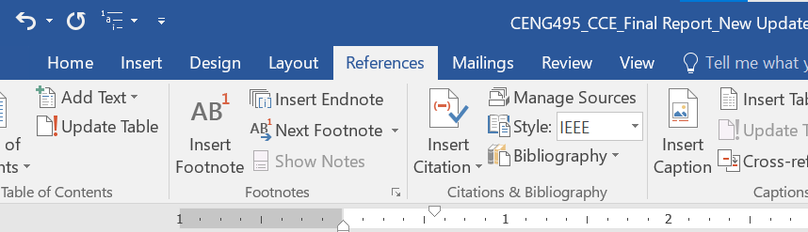
Figure .1. Menu bar of MS Word [1]

Method 2 / System 2
Describe Method 2, System 2 or common features from related work in the literature. Please respect indentation of each new paragraph. Use a reference to system 2.

Method 3 / System 3
Describe Method 3, System 3 or common features from related work in the literature. Please respect indentation of each new paragraph. Use a reference to system 3.

Methods/Systems Comparison
This paragraph in meant to highlight the advantages and shortcomings of each of the previously stated methods with respect to certain criteria.

Table 2-1: Comparison Table Based on Graphical Interfaces
Criterion 1 | System 1 | System 2 | System 3
Graphical Interface | System 1 | System 2 | System 3
Good user interface
Easy and effective navigation
Simple and professional Design
Responsive

Table 2-2: Comparison Table Based on Content and Functionality
Criterion 2 | System 1 | System 2 | System 3
Content and Functionality | System 1 | System 2 | System 3
Quality content structure
Usability
Dynamic content
Content management system

Table 2-3: Comparison Table Based on Features
Criterion 3 | System 1 | System 2 | System 3
Features | System 1 | System 2 | System 3
Security measures
Third party integration
Accessible content and location
Registration form

Conclusion and Motivation
This paragraph in meant to draw conclusions about the existing methods and the motivation behind your work. Based on comparison results and the background in chapter 1, what should be the specifications of the newly proposed methodology? What are the problems that remain unsolved by existing methods and what are you planning to do?

System Design

Introduction
This paragraph in meant to introduce the topics to be covered in this chapter.

Requirements and Specification Analysis
This section is meant to explain to the reader use cases for the project, activity diagrams, as well as specification, documentation and requirements of the project. This section can have sub-sections.

Functional Requirements
Here you have to list the operations and activities that a system must be able to perform.

Use Case Diagrams
A use case diagram is the primary form of system/software requirements for a new software program. A key concept of use case modeling is that it helps us design a system from the end user's perspective. A use case diagram is usually simple:
- It only summarizes some of the relationships between use cases, actors, and systems.
- It does not show the order in which steps are performed to achieve the goals of each use case.
Check this tutorial:
https://www.youtube.com/watch?v=zid-MVo7M-E

System Architecture
Define the overall architecture of the system. Layered, Dataflow, Multi-tier, Client-Server, etc. It is worth noting the underlying technologies to be used. Draw a figure that shows the complete system Example of such figures:
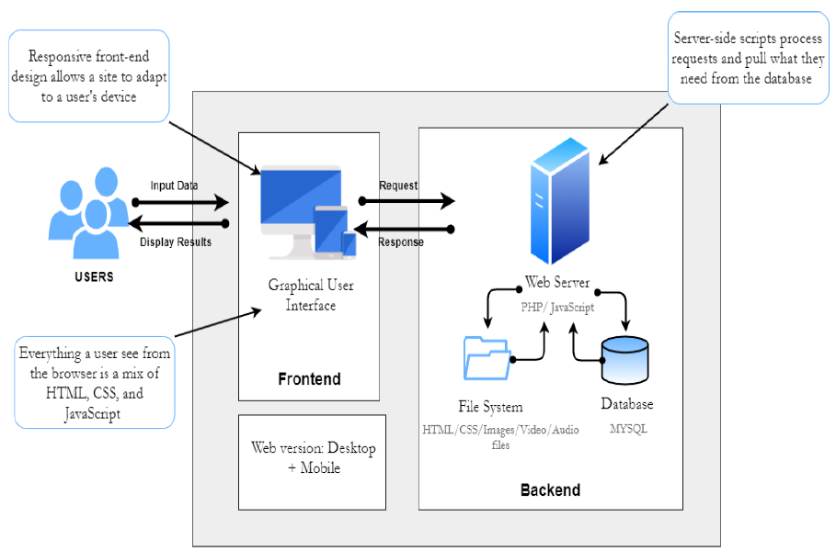
Figure ‎3-1- System Architecture

Class Diagrams
The static design view of the system. It includes all the underlying classes designed and their hierarchy. Check this tutorial: https://www.youtube.com/watch?v=UI6lqHOVHic

Sequence Diagrams
Sequence Diagrams are interaction diagrams that detail how operations are carried out. They capture the interaction between objects in the context of a collaboration. Sequence Diagrams are time focus and they show the order of the interaction visually by using the vertical axis of the diagram to represent time what messages are sent and when.
Check this tutorial: https://www.youtube.com/watch?v=pCK6prSq8aw

Activity Diagrams
Activity Diagrams describe how activities are coordinated to provide a service which can be at different levels of abstraction. Typically, an event needs to be achieved by some operations, particularly where the operation is intended to achieve a number of different things that require coordination, or how the events in a single use case relate to one another, in particular, use cases where activities may overlap and require coordination.
Check this tutorial: https://www.youtube.com/watch?v=3Hw_VXea73o

Entity-Relationship (ER) Diagrams
An entity relationship diagram (ERD) is a graphical representation of entities and their relationships to each other, typically used for modeling the organization of data within databases or information systems. Check these tutorials starting with the first one:
Tutorial 1: https://www.youtube.com/watch?v=QpdhBUYk7Kk
Tutorial 2: https://www.youtube.com/watch?v=-CuY5ADwn24

Non-Technical Aspects

Financial Viability
A cost benefit analysis of the project. Here is an example:
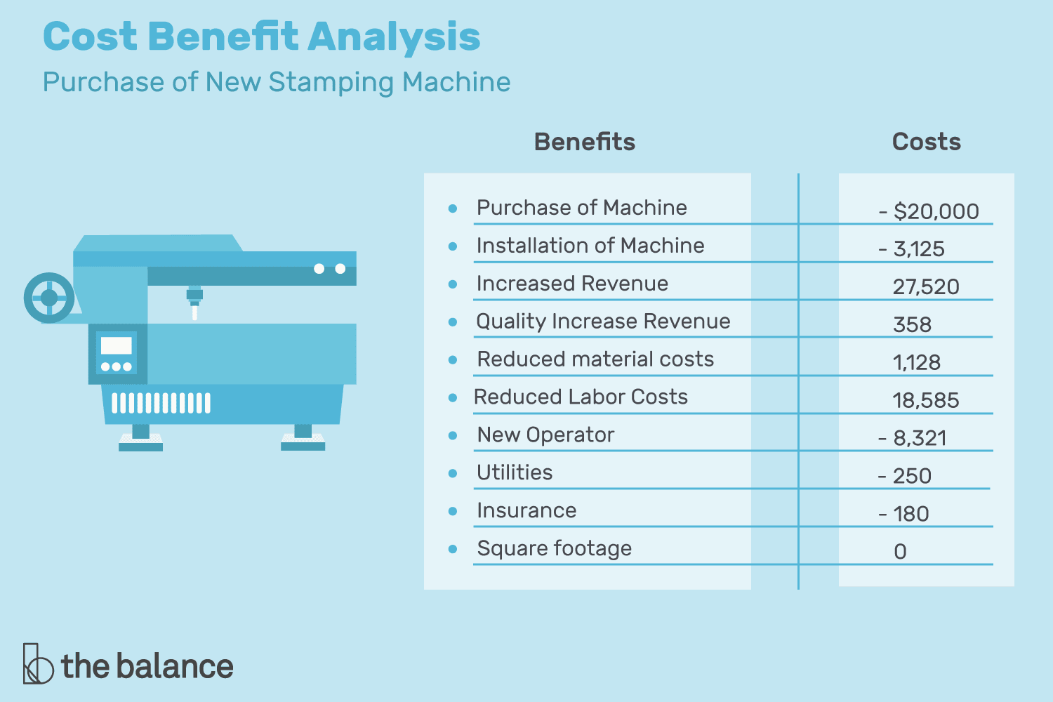
Figure ‎3-2- Cost Benefit Analysis

Stakeholders
Who will benefit? Who may be harmed? Who should have a say in how the project works?

Scope
Exactly what will be done in the project, sometimes it is helpful to state what will not be done in the project.

Risks
Things that may stop the project from achieving the goals in the scope.

Schedule and Milestones
What will be completed and when. Here is an example:
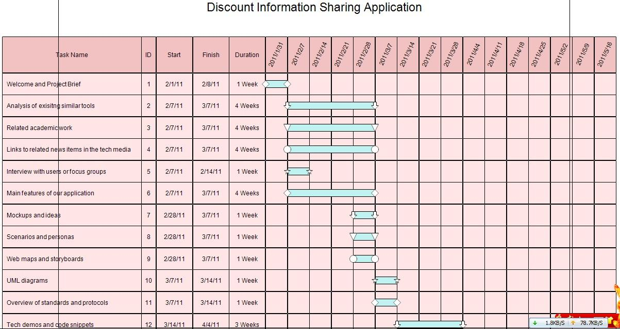
Figure ‎3-3- Scheduling Tasks and Milestones

Ethical and Social Considerations
Are there any ethical issues that should be taken into consideration when completing the design?

Environmental and Sustainability Considerations
Are there any environmental issues to write about? It is ok to write that this project has no environmental impact.

Relevant Standards
List the technical (and possibly the non-technical) standards that are relevant to your design. Examples are the WiFi standard (IEEE) and International Standardization Organization (ISO).

Conclusion
This paragraph in meant to draw conclusions highlighting the main ideas in this chapter.

Implementation/Simulation and Testing

Introduction
This paragraph in meant to introduce the topics to be covered in this chapter.

Implementation Tools
List the tools used for implementing the system. This includes hardware, compilers, IDE, frameworks, CASE tools, etc...

Implementation Summary
Description of detailed implementation steps. Demonstrate the typical code fragments (details of implementation, e.g. source code listings must be included in an appendix and saved on an accompanying CD/DVD)

Test Cases and Acceptance Criteria
Describe the test cases used and the acceptance criteria.

Conclusion
This paragraph in meant to draw conclusions highlighting the main ideas in this chapter.

Conclusion and Future Work

Conclusion
Any concluding remarks, lesson learned, etc…

Future Work
Describe the opportunities for expanding the work done in this thesis.

APPENDIX A:
Implementation Details

Any details not fit in chapter 5: e.g. detailed calculation, complex algorithms, etc…

APPENDIXB:
USER Manual

Fill in the instruction manual for using the application

APPENDIXC:
deployment and configuration Manual

Outline the deployment and configuration details in addition to any know troubleshooting techniques.

REFERENCES

[1] | J. P. Wodehouse and D. Dobrowsky, "The Economics of a Transport and or Delivery Business," 21 2 2023. [Online]. Available: https://extension.psu.edu/the-economics-of-a-transport-and-or-delivery-business. [Accessed 6 7 2023].

